Tilecoding.py
Result:

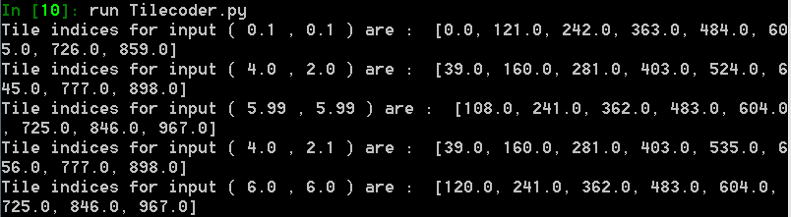
1. Every tile has a different tile number (index). Assuming that you number the tiles in the natural way, the tiles in the first tiling will run from 0 to 120, and t he tiles in the second tiling will run from 121 to 241 (why?)
My array is 11x11, it means there are 121 components in it. Index 0-120 means there are 121 components, which is the space for my array. And the second tiling starts from index 121 and end at 241.
2. A given input point will be in exactly one tile in each tiling. For example, the point from the first example in the training set above, x= 0.1 and y= 0.1, or (0.1,0.1), will be in the first tile of the first seven tilings, that is, in tiles 0, 121, 242, 363, 484, 605, 726 (why?)
For the first seven tiles, the xcoord and ycoord will always round to 0, so it will be useless when we try to use them to calculate the index.
3. In the eighth tiling this point will be in the 13th tile (why?)
This time, the xcoord and ycoord finally round to 1, so when it will affect the index now. By 11*ycoord+x, which is 12. So instead of the first tile, it increases 12 to 13th.
4. In the eighth tiling this point will be in the 13th tile, which is tile 859 (why?)
The first tile of eighth tiling is 847, and increases by 12 is 13th. Which is 859 as well.
5. If you call tilecode(0.1,0.1,tileIndices), then afterwards tileIndices will contain exactly these eight tile indices. The largest possible tile index is 967 (why?)
Because the biggest number we can choose is 5.99 in the range[0,6). And 5.99,5.99’s biggest index is 967, therefore, we cannot get an index which is bigger than 967.
6. Another check on your code is that none of the indices should be negative or greater than 967. Finally, the second and fourth examples should produce very similar sets of indices (they should have many tiles in2 common) (why?)
Because the point they pick are really close with each other. It will be no reason to have too much difference.

SuperLearn.py
test1
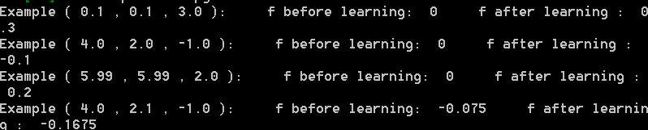
test2
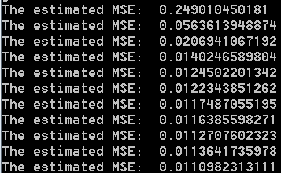

3. Run SuperLearn.py. The last line of the file calls the test1 function, which calls your learning algorithm on the four example points and prints out results. As a result of learning, your approximate function value should move 10% of the way from its original value towards the target value. The before value of the fourth point should be nonzero (why?). Make sure this is working correctly before going on to the next step.
Because we call example (4,2,-1)first, and it is very similar as (4,2.1,-1). Therefore, the function already stores some value in the weight. Because the index is similar, it can get the value from weight. Unlike others are call the first time of these index.

4. Change the last line of SuperLearn.py to call test2 instead of test1 and execute it again. The test2 function constructs 20 examples using the target function:
target = sin(x - 3) cos(y) + N(0, 0.1);
where N(0; 0:1) is a normally distributed random number with mean 0 and standard deviation 0.1. The examples are sent to learn, and then the resultant function f (after 20 examples) is printed out to a _le (f20) in a form suitable for plotting by Excel or similar. A Monte Carlo estimate of the Mean-Squared- Error in the function is also printed to standard output. The program the continues for 10,000 more examples, printing out the MSE after each 1000, and then _nally prints out the function to a _le (f10000) for plotting again. You should see the MSE coming down smoothly from about 0.25 to almost 0.01 and staying there (why does it not decrease further towards zero?).

Because the function’s limit, there will always be some error there. The function use valuable alpha to learn. However, the alpha is not small enough to make the value farther more accurate. When it really close to 0.01, it will start to increase, because the error is there.

6. After only 20 examples, your learned function will not yet look like the target function. Explain in a paragraph why it looks the way it does. If your learned function involves many peaks and valleys, then be sure to explain both their number, their height, and their width. Suppose that, instead of tiling the input space into an 11 x 11 grid of squares, you had divided into an 11 x 21 grid of rectangles, with the x dimension being divided twice as finely as the y dimension. Explain how you would expect the function learned after 20 examples to change if this alternative tiling were used.
The reason of the heights are different between these peaks and valleys represents the value for the complete graph. If you look at the graph of f10000, you will find the parts of peaks and valleys in f20 has the similar height with f10000. The rest of flat part will have the height of it keep learning. It represents the close optimal method for the value which has learned.

